**BONAFIDE CERTIFICATE**

This is to certify that the project report entitled “Production of THERMOPLASTIC POLYURETHANE”submitted by Kritika Kashyap, Shreya Sengupta, Karan Sarpal in partial fulfillment of the requirements for the award of the Degree Bachelor of Technology in Chemical Engineering is a bonafide record of the work carried out under the guidance and supervision of Professor Dr. G.S. Nirmala at VIT University, Vellore.

PROJECT GUIDE Dr. G. S. Nirmala Head of Department Chemical Engineering Division School of Civil and Chemical Engineering VIT University, Vellore

**Acknowledgement**

We would like to thank our Project Guide Dr. G. S. Nirmala, SCALE, VIT University. Without her assistance and dedicated involvement in every step throughout the process, we would not have been able to successfully complete our project. It was her constant and unwavering support and motivation which helped us exceed our limits and excel in our project.

We would like to thank Mr.Parthiban of Bayers TPU Private Limited for providing us the data required in calculations of mass and energy balances for the manufacturing process of Thermoplastic Polyurethane.

We would also like to thank Prof. Aruna Singh and Prof. Mahesh Ganesapillai for helping us and clearing our doubts enthusiastically.

Besides our advisor, we would also like to thank the other committee members: Prof. Chitra. D, Prof. Velu. S and Prof. Aslam. A, for their encouragement, keen insight as well as tough questions. They motivated us to push our boundaries and strive harder. We are truly grateful to all the panel members for supervising the progress of the project.

We would like to express our gratitude to our institute – Vellore Institute of Technology (VIT), Vellore for providing us with the right platform to undertake constructive work.

The success and final outcome of this project required a lot of guidance and assistance from many people and we are extremely fortunate to receive the same, throughout the duration of our project.

Finally we would like to express our heartfelt gratitude to our parents, teachers, batch mates, and friends for providing us with support and encouraging us through every obstacle.

**Table of Contents**

|  |  |  |
| --- | --- | --- |
| **Chapter No** | **Topic** | **Page No** |
|  | Introduction | 5 |
|  | Market Survey & Uses | 8 |
|  | Manufacturing Processes | 14 |
|  | Material Balance | 22 |
|  | Energy Balance | 26 |
|  | Equipment Design | 34 |
|  | Cost Estimation | 46 |
|  | Conclusion | 54 |

**PREFACE**

This Design Project includes various aspects of chemical product development right from the market condition evaluation to estimation of cost of the plant setup.

Chapter 1 deals with the introduction of the product Thermoplastic Polyurethane - its properties both physical and chemical. It also provides the application of TPU in various areas.

Chapter 2 contains a study of TPU in the global as well as Indian market. The gap between demand and supply is studied. The statistical data regarding the demand and supply pertaining to Indian market is studied.

Chapter 3 has a brief explanation of various processes available for the manufacture of TPU. The reason for going for the process is cited. The detailed process description along with solid works process sheet is given.

Chapter 4 includes the material balance over all the equipment and for each component for the basis of 8.4 TPD production of TPU production. Both the component and overall Mass balance has been provided. The flow rate along with % composition of each component along each stream is mentioned.

Chapter 5 contains the enthalpy balance for all the streams in the plant for each component. The total input and output energy is calculated.

Chapter 6 contains design of the polyol reactor.

Chapter 7 deals with the cost estimation of the polyol reactor and also the overall cost of the plant. The total income and profit is also calculated.

Chapter 8 summarizes the important results and conclusion.

Process flow sheet is also provided at the end of the report.

**CHAPTER1**

**Introduction**

* 1. **Thermoplastic polyurethane**
* Thermoplastic polyurethane (TPU) is a unique category of plastic created when a polyaddition reaction occurs between a diisocyanate and one or more diols. The underlying chemistry behind polyurethane was first developed by [Professor Dr. Otto Bayer](http://www.polyurethane.org/about/hall_of_fame.asp). He invented the Diisocyanate Polyaddition Process which is the base patent in the polyurethane industry.
* First developed in 1937, this versatile polymer is soft and processable when heated, hard when cooled and capable of being reprocessed multiple times without losing structural integrity. Used either as a malleable engineering plastic or as a replacement for hard rubber, TPU is renowned for many things including its: high elongation and tensile strength; its elasticity; and to varying degrees, its ability to resist oil, grease, solvents, chemicals and abrasion. These characteristics make TPU extremely popular across a range of markets and applications. Inherently flexible, it can be extruded or injection molded on conventional thermoplastic manufacturing equipment to create solid components typically for footwear, cable & wire, hose and tube, film and sheet or other industry products. It can also be compounded to create robust plastic moldings or processed using organic solvents to form laminated textiles, protective coatings or functional adhesives.
* **Aliphatic TPUs** based on isocyanates like H12 MDI, HDI and IPDI are light stable and offer excellent optical clarity. They are commonly employed in automotive interior and exterior applications and as laminating films to bond glass and polycarbonate together in the glazing industry. They are also used in projects where attributes like optical clarity, adhesion and surface protection are required.
* Thermoplastic Polyurethane is a rubber-like material that is often used in shoes, mobile device cases, sporting goods, medical devices, and drive belts.

**1.2 Physical Properties**

* Appearance : Transparent , spherical pellets, rubber like
* Colour: Black
* Odour: odourless
* Density : 1.15-1.19 g/cm3
* Tensile strength : 30-40 Mpa ~ 5076 psi
* Tear Strength : 285 pli
* Compression Set/ 70h @ 23C 34%   
  Compression Set/ 24h @ 70C 48%
* Abrasion Loss: 20-35 mm3
* Glass transition: -30 to -45 ‘C
* Specific Gravity : 1.18
* Boiling Point : not available
* Melting Point : 130-300’C   
   154-419 F ( over range of different grades)
* Solubility in water : not available
* Viscosity : 14850 to 35000 mPa.s ASTM D445
* Flash Point : not applicable
* Vapour Pressure :
* Water Absorption (73°F, 24 hr): 0.3 - .4 % ASTM D570
* Surface Resistivity: 1.0E+6 to 2.5E+10ohms ASTM D257
* High wear resistance
* Flexibility over a wide range of temperature
* High elasticity over the entire hardness rang
* Excellent resistance to oils, greases and many solvents
* Good resistance to weathering
* Intrinsically soft, no plasticiser needed
* Excellent resistance to high-energy radiation

**1.3 Chemical Properties**

* During handling and use,product can cause static discharge. In the presence of flammable materials a fire and/or explosion may occur. Molten material may cause thermal eye burns. Molten material may cause thermal skin burns. Processing vapors may cause respiratory tract irritation
* General Only normally needed for thermal burns and for inhalation of smoke from burning material
* Eye contact: Check for and remove any contact lenses. In case of contact, immediately flush eyes with plenty of water for at least 15 minutes. Get medical attention.
* Skin contact: Molten material can cause severe burns. Do NOT try to peel molten polymer from the skin. Immediately immerse in or flush with large amounts of cold water to dissipate heat. Cover with gauze and get prompt medical attention.
* Inhalation : Remove patient from exposure, keep warm and at rest. Obtain medical advice IMMEDIATELY.

**1.4 Application and Uses**

From the gear knobs in our hand, athletic shoes or ski boots on our feet to materials in construction, agriculture or other industries we depend on daily – product designers, engineers and manufacturers rely on our diverse portfolio of thermoplastic polyurethanes. See for yourself and learn about our most important industries and applications.

Automotive

* Gear Knobs
* TPU-Surface (Skin) for instrument panels
* Chassis spring seatings
* Tamber doors
* Door handles, Cupholders
* Pedal covers
* Door damper, Sealing

# Industrial Mechanical

* Wearing parts: mine screens, strippers, cyclones
* Wheels and solid tyres: wheels with polyamide or metal hubs for machines, trucks, escalators
* Rollers: transport, support and guide rollers, rollers for office equipment
* Seals: U- and V-packing rings, O-rings, cup seals, inverted cup seals and V-shaped seals
* Damping components: spacers and grippers, pickers, handles for pneumatic drills
* Drive elements: clutch components, timing belts, round belts, cog wheels.

Agriculture

In addition to animal identification tags there are several more TPU applications in the field of agriculture. Desmopan® TPU also helps farmers to sow and harvest their crops. All kinds of different harrows and picking prongs, for example, are made of TPU.

Sport &Leisure

* Ski boots, inline skates
* Ice Hockey Boots
* Hiking and climbing boots
* Flexible soles for sports shoes
* Parts for ski bindings
* Roller skate wheels
* Ski edges
* Ski and snow board surfaces
* Motorcross boots

Other applications

* Household and electrical appliances
* Tools
* Medicl Technology
* Toys
* Fabric Coating
* Films

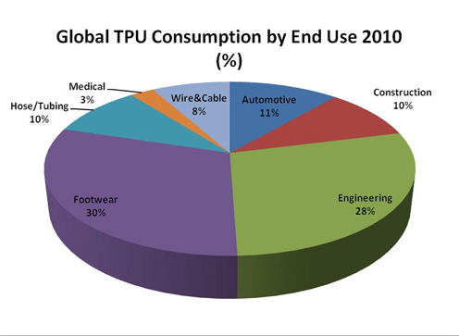

**1.5 End Use Consumption**

Thermoplastic Polyurethane has a variety of applications in the industry. It can be used for Furniture ,Automobile seats, Houses, sculptures, and decorations ,Filling of spaces and cavities, Water vessels, Flexible plastics ,Varnish, Wheels, Automotive Parts, Electronic components, Adhesives ,Abrasion resistance , Architectural Glass Lamination ,Auto-Body Side Molding ,Automotive Lumbar Supports ,Caster Wheels ,Cattle Tags ,Constant Velocity Boots (Automotive) ,Drive Belts ,Film and Sheet, Fire Hose Liner ,Flexible Tubing ,Food Processing Equipment , Footwear—sport shoe soles ,Hydraulic Hoses, Hydraulic Seals ,Inflatable Rafts, In-Line Skates ,Magnetic Media.

**CHAPTER 2**

**2.1 Market Analysis**

World’s largest market store-RESEARCH AND MARKETS has made a report regarding the identification of the performance of Thermoplastic Polyurethane (TPU) in the overall market. This report is subdivided by application, end user industries and also by geographical analysis in terms of both volume and revenue from 2010 till 2018. By application the global TPU market includes injection molding, extrusion, adhesives and sealants, and paints and coatings in terms of kilo tons as volume and USD million in terms of revenue from 2010 and forecasted till 2018.  


***Worldwide Consumption of PU.***

According to Transparency Market Research, the TPU market by end users includes industries such as automotive, construction, electronics and appliances, hose and tubing, footwear, wire and cable and others which includes industrial insulation Engineering because of their high tensile strength, abrasion resistance, and low temperature properties. In addition, thermoplastic polyurethanes possess a number of physical properties that no other TPEs can provide.

Some of the key players of the TPU market profiled in this report are BASF, Bayer AG, Huntsman Corporation, Dow Chemicals, and Lubrizol and so on.

In terms of volume, the Global Thermoplastic Polyurethane market shipped 0.448 million tons in 2014 and is expected to increase to 0.560 million tons by 2019, growing at a CAGR of 4.56 percent.

Increased demand from the Automotive industry is one of the major drivers of increasing production of TPU. Thermoplastic polyurethane is replacing the metals used in the manufacture of automobile parts because it is light in weight and has higher impact resistance. Increased use of thermoplastic polyurethane in medical applications is another growth driver.

IROGRAN®, AVALON®, KRYSTALGRAN® and IROSTIC® are the four main TPU brands produced by the polyurethanes division of Huntsman. Available in an array of different grades,

each has its individual characteristics and can be tailored for either basic plastic product applications or more complex engineering projects.

Regardless of brand, all TPU grades have some common performance traits that set them apart from other plastic materials. These typically include:

• High abrasion resistance

• High elasticity across the entire hardness range

• Excellent low-temperature and impact strength

• Resilience to oils, greases and numerous solvents

• Good flexibility over a wide temperature range

• Robust weather and high-energy radiation resistance

• Pleasant tactile properties

• Suitability for bonding and welding

• Ease of coloring

• Recyclability

For applications with specific requirements, it is possible to change a TPU’s physical attributes and production values. Distinct performance properties can be achieved by:

• Varying the type of polyol used

• Adjusting the ratio of other raw materials

• Changing the reaction conditions under which processing takes place

• Using additives like UV stabilizers, mold release agents and flame-retardants.

BASF is the leading global player in MDI and TDI with regional world scale plants.

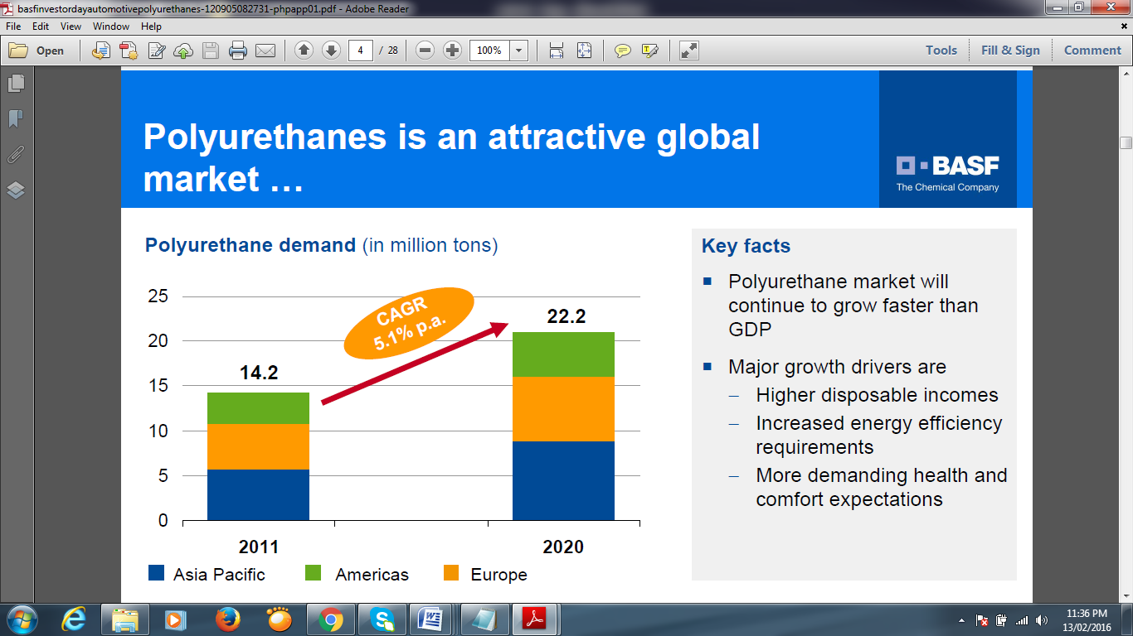

In South India, **Bayer TPU Private Limited**, a growth oriented Bayer AG, Germany subsidiary, manufactures Thermoplastic Polyurethane (TPU), marketed under the registered Bayer AG brand name Desmopan. The company's manufacturing facility at Cuddalore, Tamil Nadu, contributes more than 2000 MT annual capacity to feed both the domestic market as well as Europe and Far East customers through BayeCs international marketing network. While the majority of sales are still generated through exports, local sales are expected to pick up.   
The quality of Desmopan (TPU) manufactured at Cuddalore conforms to specification laid down by Bayer AG and testing these products periodically enforces strict quality control.   
  
The company has pioneered the development of TPU applications in wide ranging industry segments viz. injection moulded components in automotive, textile, shoe, castor wheels- extrusion of cable sheathing, pneumatic tubing, solution coatings, adhesives etc. Bayer TPU Private also represents Wolff Waisrode, another Bayer Group Company, in India for their thermoplastic elastomer films used in a range of applications viz. automotive industry, tank lining, conveyor belts, membrane packaging, medical/surgical drapes etc.

Another TPU manufacturing company in southern India, **G-STAR POLYMERS PLASTICS** inTiruvallur, Tamil Nadu, has acquired a reputed name in the realm of offering comprehensive range of all Thermoplastics plastic products. They are a trusted **Manufacturer** and **Supplier** of high quality range of **Recycling, Colouring and Compounding of all Thermoplastics such as LDPE Granules, Recycled LDPE Granules, Polyethylene Granules, HDPE Granules, LDPE Polyethylene, Nylon, Polypropylene, Polystyrene, Polycarbonates,** Acrylonitrile-Butadiene-Styrene**, Thermoplastic Rubber, Thermoplastic polyrethane.** Moreover, they are also engaged in rendering value added services like **Thermoplastic Recycling, Coloring & Compounding Job Works Can Done** etc.

With the support of a sound manufacturing unit and a competent workforce, they have been catering to the needs of various domains like automobile, electronic, home appliances, etc.

**2.2 Global Producers**

BASF (Germany)  
Bayer (Germany)  
Huntsman  
Gala Industries

**CHAPTER 3**

**3.1 Production Processes**

Polyol, MDI and 1, 4-Butanediol are the main reactants for the formation of TPU.

**Polyol Reactor:** Adipic acid and 1, 4-Butanediol are made to react to produce polyester Polyol. Water liberated from the reaction is condensed and treated as effluent. Along with the water some amount of organic material also gets produced which needs to be analysed for the presence of monomers and oligomers.

**Polyol Blend Tank:** Prepared polyol is melted to liquid state and is fed to the blend tank with additives in a very negligible amount as per application.

The flowrate of raw materials is calibrated to avoid polymer build up. The calibrated reactants cannot be reused again as it gets exposed to air and gets a colour due to oxygen presence.

**MDI and BDO Charging:** MDI and BDO supplied to the tanks are charged after melting. The flowrate is maintained to maintain the polymer consistency and final quality of the product.

**FettAlkohol Tank:** Fettalkohol C-8 98% is a chain terminating agent which controls the side reaction of a product which is not desired to be formed.

**Extruder:** Co-rotating twin reactive screw extruder is used. Mixer product and BDO are sent to the extruder and are fed one by one, with few minutes gap and the material is collected in waste drums till all raw material are mixed and uniform polymer is formed before sending the polymer to pelletisation process. The technique used for making the pellets from the resin is called *Under water pelletisation*. Resin from the extruder passes through a DIE and then pulled out in the required cross sectional area and is cut by the blades of the pelletiser , then cooled by chilled water. A lot of waste is also removed due to pelletiser upset as a result of improper polymer build up.

**Dryers:** A centrifugal dryer is used. Here the pellets and water gets separated. This water is recycled. The final moisture content present in the pellets after dehumidification ( hot air dryer) is 0.05%.

**Sieving:** The desired shape of pellets is between 3-5mm. Hence the bigger sizes are left on the upper sieves and the required size of pellets are obtained.  
**Packing:** The final product is packed and dispatched to various industries.

**3.3 PROCESS CHEMISTRY**

**Polyurethane** (**PUR** and **PU**) is a polymer composed of a chain of organic units joined by carbamate (urethane) linkages. Polyurethanes are produced by reacting an isocyanate containing two or more isocyanate groups per molecule (R-(N=C=O)n ≥ 2) with a polyol containing on average two or more hydroxy groups per molecule (R'-(OH)n ≥ 2), in the presence of a catalyst. Polyurethane products often are simply called “urethanes”.



***Fig: Polyurethane synthesis, wherein the urethane groups — NH-(C=O)-O- link the molecular units.***

Polyurethanes are in the class of compounds called reaction polymers, which include epoxies, unsaturated polyesters, and phenolics. The properties of a polyurethane are greatly influenced by the types of isocyanates and polyols used to make it. Long, flexible segments, contributed by the polyol, give soft, elastic polymer. High amounts of crosslinking give tough or rigid polymers. Long chains and low crosslinking give a polymer that is very stretchy, short chains with lots of crosslinks produce a hard polymer while long chains and intermediate crosslinking give a polymer useful for making foam.

A TPU is a multi-phase block copolymer that is created when three basic raw materials are combined together in a specific way. The individual components required to produce a TPU are:

• A polyol or long-chain diol

• A chain extender or short-chain diol

• A diisocyanate

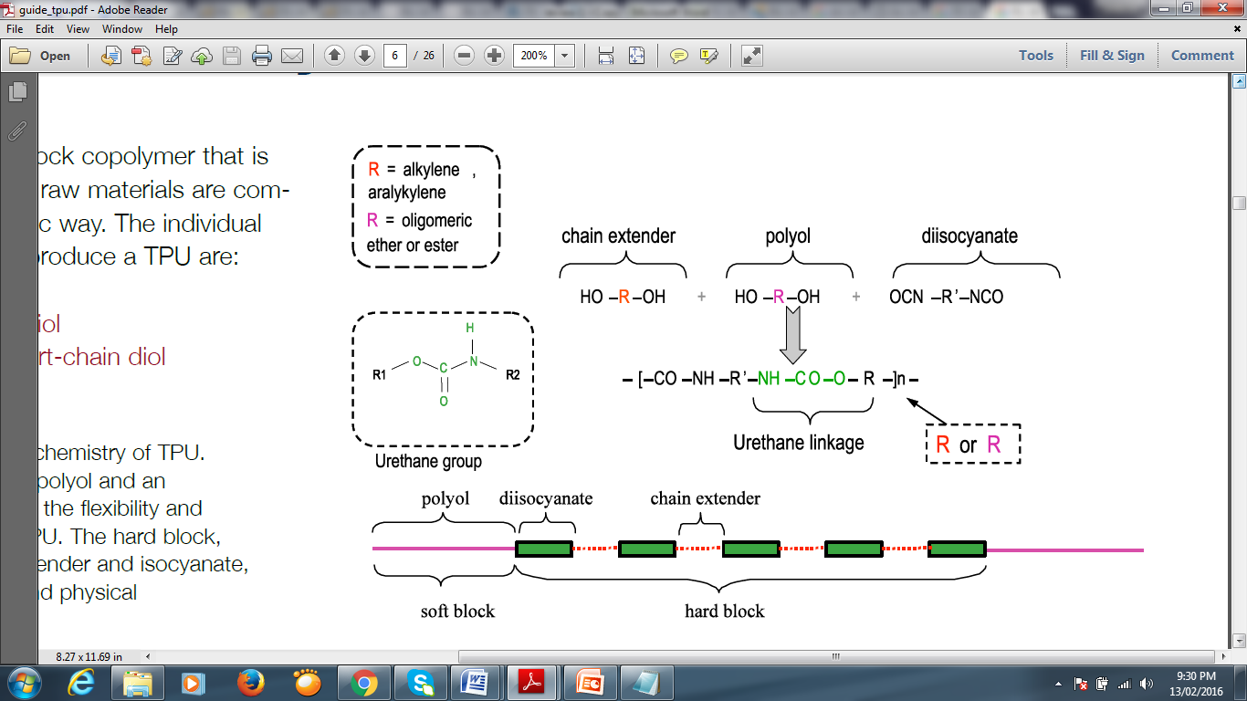

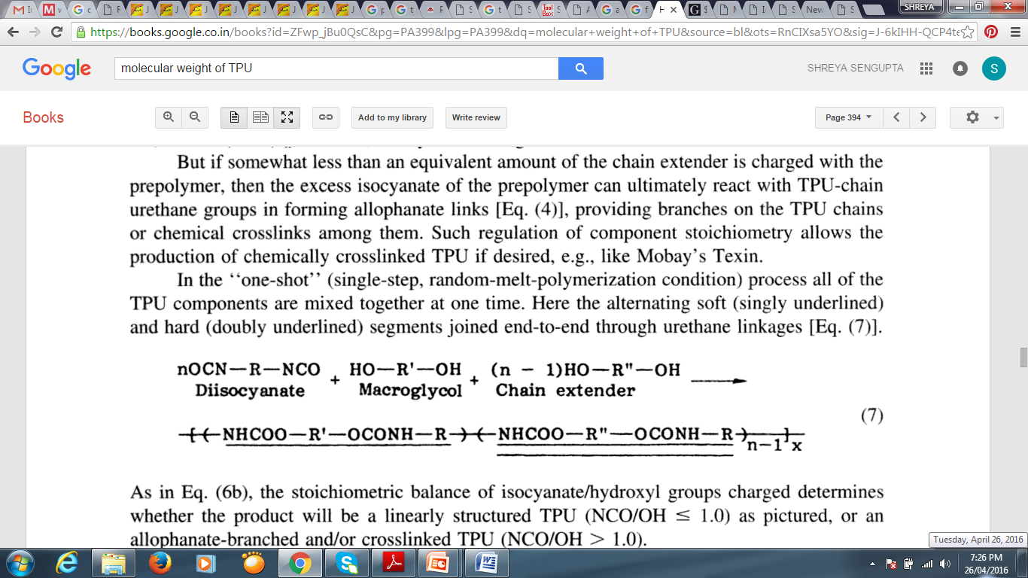

.

**Generalized urethane reaction**

The polymerization reaction makes a polymer containing the urethane linkage, - RNHCOOR'- and is catalyzed by tertiary amines, such as 1,4-diazabicyclo[2.2.2]octane (also called DABCO or TEDA), and metallic compounds, such as dibutyltin, dilaurate, orbismuth, octanoate. This is often referred to as the gellation reaction or simply gelling.

If water is present in the reaction mixture (it is often added intentionally to make foams), the isocyanate reacts with water to form a urea linkage and carbon dioxide gas and the resulting polymer contains both urethane and urea linkages. This reaction is referred to as the blowing reaction and is catalyzed by tertiary amines like bis-(2-dimethylaminoethyl)ether.

One of the most desirable attributes of polyurethanes is their ability to be turned into foam. Making a foam requires the formation of a gas at the same time as the urethane polymerization (gellation) is occurring. The gas can be carbon dioxide, either generated by reacting isocyanate with water or added as a gas or produced by boiling volatile liquids. In the latter case heat generated by the polymerization causes the liquids to vaporize. The liquids can be HFC-245fa (1,1,1,3,3-pentafluoropropane) and HFC-134a (1,1,1,2- tetrafluoroethane), and hydrocarbons such as n-pentane.

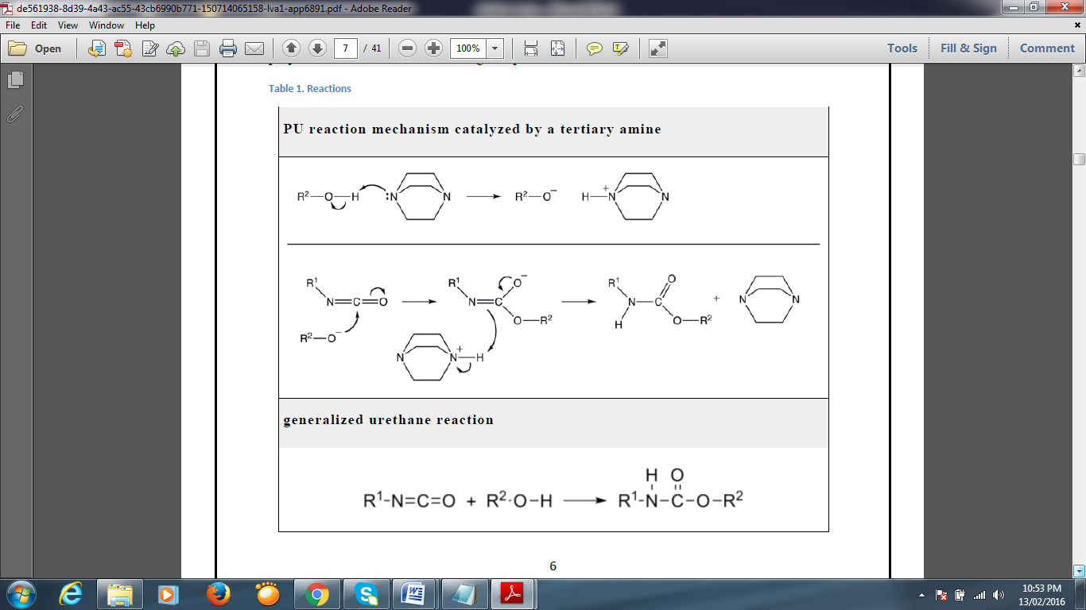

**Carbon dioxide gas formed by reacting water and isocyanate**

When water is used to produce the gas, care must be taken to use the right combination of catalysts to achieve the proper balance between gellation and blowing. The reaction to generate carbon dioxide involves water molecule reacting with an isocyanate first forming an unstable carbamic acid, which then decomposes into carbon dioxide and an amine. The amine reacts with more isocyanate to give a substituted urea. Water has a very low molecular weight, so even though the weight percent of water may be small, the molar proportion of water may be high and considerable amounts of urea produced. The urea is not very soluble in the reaction mixture and tends to form separate "hard segment" phases consisting mostly of polyurea. The concentration and organization of these polyurea phases can have a significant impact on the properties of the polyurethane foam.

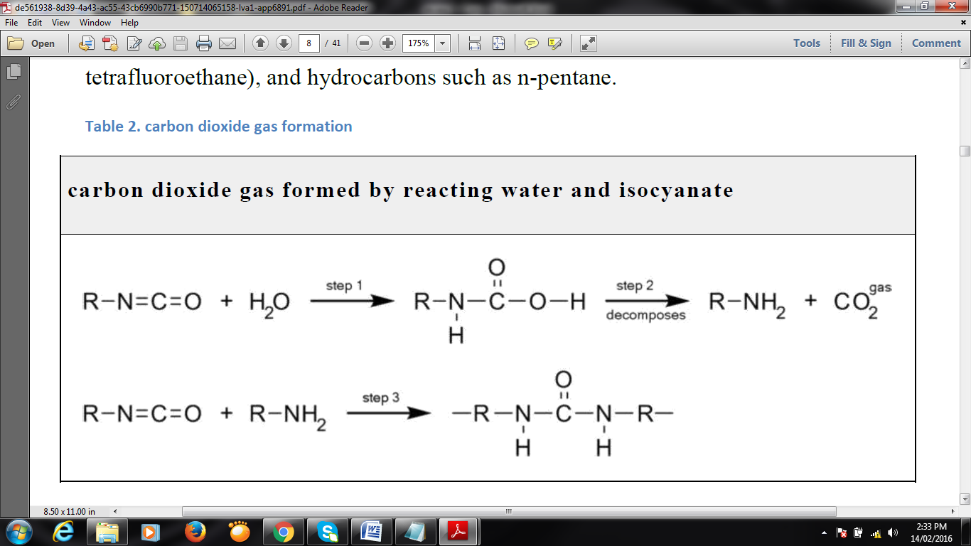

Thermoplastic Polyurethane is soft and processable when heated, hard when cooled and capable of being reprocessed multiple times without losing structural integrity.

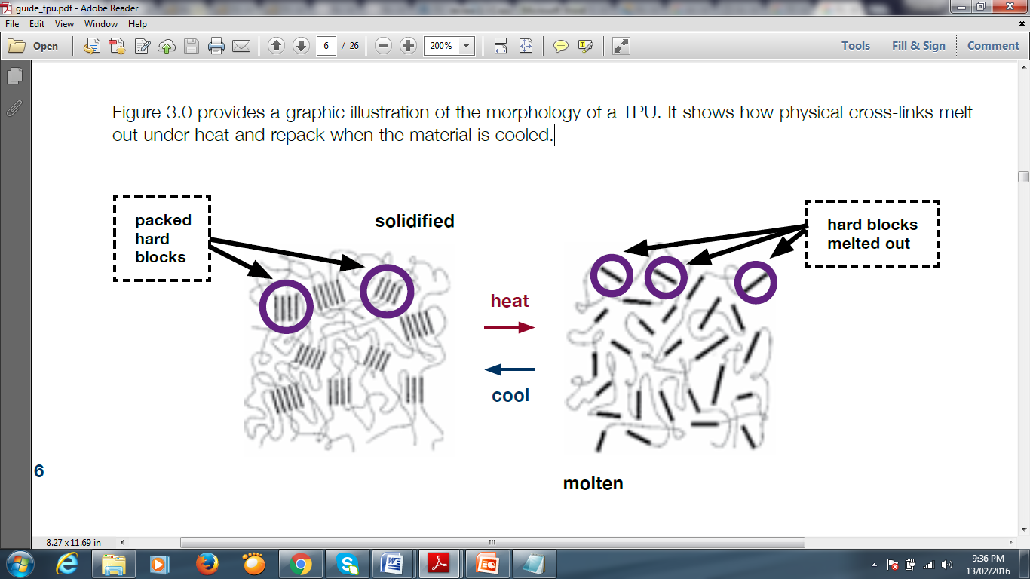

***Figure provides a graphic illustration of the morphology of a TPU. It shows how physical cross-links melts out under heat and repack when the material is cooled.***

**RAW MATERIALS**

Urethane functional groups are based in isocyanate and alcohol reaction:

The use of bifunctional isocyanates and diols will produce the so called polyurethanes. The first commercial production of flexible PU foams, based on the reaction between an aromatic isocyanate and a polyester polyol, was carried out in 1954.

However, these foams were unable to withstand the severe humidity and temperature conditions in which they were used, and thus foams based on polyether polyols were developed. This second generation foams provided better durability as well as comfort. A major advancement in PU technology was the introduction of the „one-shot‟ system using new catalysts and silicone-based surfactants. In the one-shot process; the isocyanate, polyol, water, and other ingredients are rapidly and intensively mixed and immediately poured to carry out the foaming.

**Isocyanates**

The polyurethane industry is mostly based on isocyanate chemistry. The functional group of isocyanates, -NCO, is capable of undergoing several different types of chemical reactions and is highly reactive toward proton-bearing nucleophiles such as alcohols, water, amines and urethanes [39]. The isocyanate, which provides the NCO groups that are essential to the PU production reaction, is quite important to the final physical and chemical properties of the foam. Although there are many isocyanates available in the market, most all of the PUs are based only on two of them. These are toluene diisocyanate (TDI), and the diphenylmethane diisocyanate (MDI) and its derivatives. The first is used mainly in the production of low-density foams, but its use under certain working conditions was not advisable for safety issues, giving therefore rise to the development of MDI.

The MDI used in PU production is a dark colored liquid, less hazardous than TDI due to its lower vapor pressure at normal temperatures . Despite this, MDI is still a very reactive and toxic reagent. MDI is prepared from aniline, formaldehyde, and phosgene.

TDI and MDI are generally less expensive and more reactive than other isocyanates. Industrial grade TDI and MDI are mixtures of isomers and MDI often contains polymeric materials. They are used to make flexible foam (for example slabstock foam for mattresses or molded foams for car seats), rigid foam (for example insulating foam in refrigerators) elastomers (shoe soles, for example), and so on. The isocyanates may be modified by partially reacting them with polyols or introducing some other materials to reduce volatility (and hence toxicity) of the isocyanates, decrease their freezing points to make handling easier or to improve the properties of the final polymers. Aliphatic and cycloaliphatic isocyanates are used in smaller volumes, most often in coatings and other applications where color and transparency are important since polyurethanes made with aromatic isocyanates tend to darken on exposure to light. The most important aliphatic and cycloaliphatic isocyanates are 1,6-hexamethylene diisocyanate (HDI), 1- isocyanato-3-isocyanatomethyl-3,5,5-trimethyl-cyclohexane (isophorone diisocyanate, IPDI), and 4,4'-diisocyanato dicyclohexylmethane, (H12MDI or hydrogenated MDI).



***Figure : The aromatic methylene diphenyl diisocyanate, MDI***

**Polyols**

Polyols are polymers having on average two or more hydroxyl groups per molecule. Polyether polyols are mostly made by polymerizing ethylene oxide and propylene oxide. Polyester polyols are made similarly to polyester polymers. The polyols used to make polyurethanes are not "pure" compounds since they are often mixtures of similar molecules with different molecular weights and mixtures of molecules that contain different numbers of hydroxyl groups, which is why the "average functionality" is often mentioned. Despite them being complex mixtures, industrial grade polyols have their composition sufficiently well controlled to produce polyurethanes having consistent properties. As mentioned earlier, it is the length of the polyol chain and the functionality that contribute much to the properties of the final polymer. Polyols used to make rigid polyurethanes have molecular weights in the hundreds, while those used to make flexible polyurethanes have molecular weights up to ten thousand or more.



Acid number is defined as the number of milligrams of potassium hydroxide (KOH) required for neutralizing the acid in 1 gram of resin (mg of KOH/ g of polyol). The used indicator was phenolphthalein. This is a direct measure of the degree of polyesterification, since acid groups which have react to form ester groups will not react with KOH. Acid number is the physical constant most frequently used as a process control during the synthesis of a resin. It is observed that as the reaction proceeds, the acid number decreases in a regular manner becoming constant as the reaction reaches toward completion. The acid number is inversely proportional to the MW of a polyol chain.

**CHAPTER 4**

**Material Balance**

The process shows a maximum conversion rate of 96%.

Production of TPU : 350 Kg/hr = 8400 Kg/day = 8.4 tons/day

Composition of the TPU pellets ( excluding water content)

|  |  |
| --- | --- |
| POLYOL | 48.06% |
| BDO | 10.14% |
| MDI | 41.04% |
| Additives | 0.76% |

The additives used are :

|  |  |
| --- | --- |
| Finawax | 0.36% |
| Edenol | 0.25% |
| Irgonax | 0.10% |
| Carbodiimid | 0.05% |

**Calculations:**

Since the mass flow rate is 350 kg/hr for TPU pellets. It has 0.05% of moisture and 99.95% of solids and the percentage composition of BDO is 10.14% of the solids. Therefore, the mass flow rate of **stream 9** = 10.14% x 99.95% x 350  
 = 0.1014 x 0.9995 x 350   
 = **35.47 Kg/hr = 0.851 tons/day**.

The percentage composition of polyol is 48.06% of solids. Therefore, the mass flow rate of **stream 4** = 48.04% x 99.95% x 350 = 0.4806 x 0.9995 x 350  
 = **168.125 kg/hr = 4.035 tons/day.**

Now according to the reaction:

*Adipic acid 1,4-butanediol butanediol adipate water  
 (polyester polyol)*

Where ***R*** = ***C4H8***

1 mole Adipic acid—2 moles BDO—1 mole polyol—2 moles water

Therefore, mass flow rate of Adipic acid i.e **stream 1** = (168.125/290) x (1x146)  
 = **84.642 kg/hr =2.031 tons/day.**

Mass flow rate of BDO i.e **stream 2** = [ (168.125/290) x 2 ] x (2 x 90)  
 = **208.7 kg/hr = 5.009 tons/day.**

Similarly, mass flow rate of water effluent i.e **stream 3** =(168.125/290)x2 x (2x18)  
 = **41.74 kg/hr = 1.0017 tons/day.**

The percentage composition of MDI is 41.04% of solids. Therefore, the mass flow rate of **stream 6** = 41.04% x 99.95% x350 = 0.4104 x 0.9995 x 350 =143.568 kg/hr.

we know that there is a loss of 2.25% of 4% of 350 i.e 0.315 kg/hr. Therefore (143.568 - 0.315) = **143.25 kg/hr = 3.43 tons/day.**

Stream 5is a blend of polyol and additives. The percentage composition of additives is 0.76% of solids.   
Therefore mass flow rate of **stream 5** = (0.76% x 99.95% x 350) + 168.125  
 = (0.0076 x 0.9995 x 350) + 168.125  
 = **170.78 kg/hr = 4.098 tons/day.**

Therefore, now mass flow rate of **stream 7=stream 8** = 170.78 + 143.25  
 = **314.037 kg/hr = 7.536 tons/day.**

The mass flow rate of **stream 10** = 314.037+35.47= **349.51kg/hr =8.388 tons/day.**

Since the extruder startup loss and pelletiser upset loss contribute to a total loss of 10.1% of 4% of 350 = 11.34 +2.016 =13.356 kg/hr.

Therefore, mass flow rate of **stream 11** = 349.51 – 13.356  
 = **336.154kg/hr = 8.067 tons/day.**Now with 21000 kg/hr of chilled water for wash of pellets from extruder and 20% absorption of water by the pellets.  
 Therefore mass flow rate of **stream 12** = **21000 kg/hr = 504 tons/day**   
and that of **stream 13** = 80% of 210 00kg/hr = **16800 kg/hr = 403.2 tons/day.**  
Mass flow rate of **stream 14 = stream 15** = 336.154 + (20% of 21000kg/hr )   
 = 336.154 + 4200   
 = **4536.154 kg/hr = 108.86 tons/day.**

Since the centrifugal dryer is efficient in removing 60% of the moisture content , therefore mass flow rate of **stream 16** = 60% of 4200   
 = **2520** **kg/hr = 60.4 tons/day.**

After removing 60% moisture, the mass flow rate of **stream 17 = stream 18** = (4536.154 - 2520) = **2016.154 kg/hr = 48.387 tons/day.**

The hot air dryer removes moisture upto 0.05% of 350 i.e. the moisture content in stream 20 is 0.05% x 350 = 0.175 and moisture content in stream 18 = (4200 -2520) =1680.  
This implies mass flow rate of **stream 19** = (1680 - 0.175) = **1679.82 kg/hr   
 = 40.315tons/day.**

Mass flow rate of **stream 20** = (2016.154 – 1679.82) = **336.329 kg/hr  
 = 8.07 tons/day.**Therefore % conversion = 336.329 / 350 x 100 = 96.09%

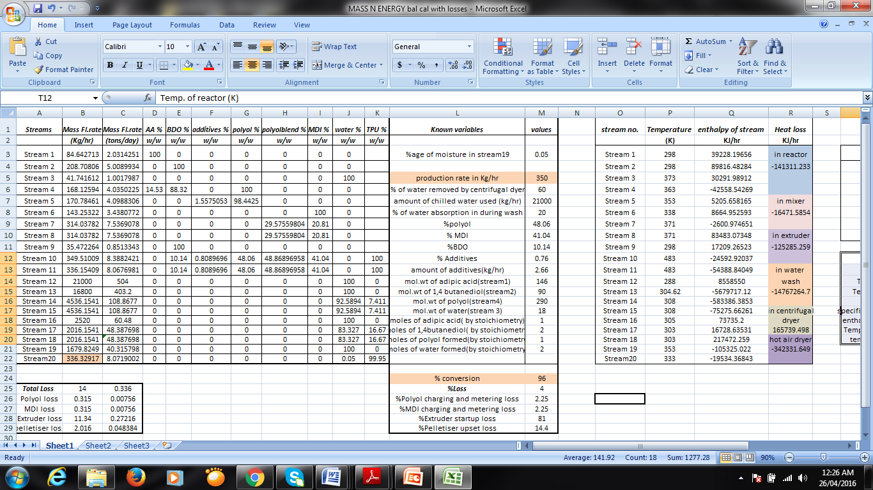

**CHAPTER 5**

**ENERGY BALANCE**

|  |  |  |  |
| --- | --- | --- | --- |
| ***stream*** | ***Temp*** | ***specific heat, Cp*** | ***∆Hf*** |
|  | ***(K)*** | ***(KJ/kg)*** | ***(KJ/mol)*** |
| ***water*** | ***298*** | ***4.18*** | ***-242*** |
| ***adipic acid*** | ***298*** | ***2.43694*** | ***-994.3*** |
| ***BDO*** | ***298*** | ***2.219263205*** | ***-503.25*** |
| ***polyol*** | ***363*** | ***1.89*** | ***-1250*** |
| ***MDI*** | ***338*** | ***1.8*** | ***-360*** |
| ***TPU*** | ***333*** | ***1.65946*** | ***-1393*** |

|  |  |
| --- | --- |
| ***Temp. of reactor (K)*** | ***493*** |
| ***Temp. of Extruder (K)*** | ***523*** |
| ***Temp. in hot air dyer(K)*** | ***368*** |
| ***Temp of water effluent(K)*** | ***318*** |
| ***Temp of mixer(K)*** | ***373*** |
| ***specific heat of mixer outlet(KJ/kg)*** | ***1.78*** |
| ***enthalpy of mixer outlet stream*** | ***-1483*** |
| ***Temp of chilled water wash (K)*** | ***385.5*** |
| ***temp in centrifugal dryer(K)*** | ***298*** |

**Energy Balance on Reactor:**

**POLYOL REACTOR**

**Tr = 493 K**

**Q = -141057 KJ/hr**

**Adipic acid**

39228.196 KJ/hr

T1 =298 K

**1,4-butanediol**

89816.482 KJ/hr

T2 = 298 K

**Butanediol adipate (Polyol)**

* 42558.542 KJ/hr

T4 = 493 K

**Water effluent**

30291.989 KJ/hr

T3 = 318 K

**1**

**2**

**3**

**4**

**For Adipic Acid**

= (-994.3) + (84.685)(2.4369)(493-298) = 39228.19656 KJ/hr

**For 1,4 Butandiol**

= -503.25+ (208.812)( 2.219 ) (493- 298) = 89816.482 KJ/hr

**For Water**

= (-242) + (41.74)( 4.18 ) (493- 318) = 30291.98912 KJ/hr

**For Polyol**

= (-1250 ) + (168.12)(1.89 ) (363- 493) = - 42558.542 KJ/hr

**Heat Loss In Reactor**

Q1  = - 141311.23 KJ/hr

**Energy Balance On Blending Tank**

A blending action is observed. The polyol released from the polyol reactor is mixed with additives like Iragnox and Carbodiimid with the help of an agitator which results in a 10% loss in energy.

Q2 =  Q1 – 0.1*Q1 = - 126951 KJ/hr

**Energy Balance On Mixer**

**Polyol Blend   
(Polyol+ Additives)**

5205.658 KJ/hr

T5 = 353 K

**MDI  
(Methylene diphenyl diisocyanate)**

8664.952593 KJ/hr

T6 = 338 K

**Intermediate product** -2600.94 KJ /hr

T7 =371 K

**MIXER**

Tm= 373 K

Q= -16471 KJ/hr

**5**

**6**

**7**

**For Polyol**

= (-1250 ) + (170.78)(1.89 ) (373- 353) **= 5205.658 KJ/hr**

**For Methylene Diamine Isocyanate**

= (-360) + (143.25)(1.8) (373-338) = **8664.952593 KJ/hr**

**For Stream 7**

= (-1483) + (314.03)(1.78) (371-373) **= -2600.9746 KJ/hr**

**Heat Loss In Mixer**

Q3 = **-16471.585 KJ/hr**

**Energy Balance On Extruder**

**TPU Pellets**

-24586.483KJ/hr

T10= 483 K

**EXTRUDER  
 &  
 PELLETISER**

Q= -125273.4 KJ/hr

T e= 523 K

**8**

**9**

**10**

**1,4-butanediol**

17209.26523 KJ/hr

T9= 298 K

**Mixer product**

83483.07348 KJ/hr

T8= 371 K

**For Stream 8**

= (-1483) + (314.03)(1.78 ) (523-371) **= 83483.07348 KJ/hr**

**For 1,4 Butandiol**

= (-503.25) + (35.47)(2.219 ) (523- 298) = **17209.26523 KJ/hr**

**For Stream 10**

= (-1393 ) + (349.51)(1.659 ) (483- 523) = **-24592.9 KJ/hr**

**Heat Loss In Extruder**

Q4 = **-125285.26 KJ/hr**

**Energy Balance of Water Wash**

**TPU Pellets**

-54373.74 KJ/hr

T11= 483 K

**Chilled water  
 wash**

**Q=** **-14767265 KJ/hr**

**Tw = 385.5 K**

**Chilled Water**

8514660 KJ/hr

T12 =288 K

**Water out**

-5679717.12 KJ/hr

T13 = 304.62 K

**11**

**12**

**13**

**14**

**Wet TPU pellets**

-594122.77 KJ/hr

T14 = 308 K

**For Extruder Pellet**

= (336.154)(1.659 ) (385.5- 473) **= -54388.84049 KJ/hr**

**For Inlet Chilled Water**

= (21000)(4.18 ) (385.5- 288) **= 8558550 KJ/hr**

**For Outlet Water**

= (16800)(4.18 ) (304.62-385.5) = **-5679717.12 KJ/hr**

**For Wet TPU Pellets**

= (4536.154)(1.69 ) (308- 385.5) **= -583386.3853 KJ/hr**

**Heat Loss In Water Wash**

Q5 = **-14767265**

**Energy Balance On Centrifugal Dryer**

**Water removed**  
73735.2 KJ/hr  
T16 = 305 K

**Wet TPU pellets**-76660.93 KJ/hr

T15 = 308 K

**Partially dried pellets**  
17036.501 KJ/hr

T17 = 303 K

**CENTRIFUGAL  
 DRYER**

**Q = 167432 KJ/hr**

**Tc = 298 K**

**15**

**16**

**17**

**For Wet TPU Pellets**

= (4536.15)(1.69) (298- 308) **= -75275.66261 KJ/hr**

**For Outlet Water**

= (2520)(4.18) (305- 298) **= 73735.2 KJ/hr**

**For Dry TPU**

= (2016.154)(1.69) (303- 298) = **16728.6 KJ/hr**

**Heat Loss In Centrifugal Dryer**

Q6 = 165739.498 KJ/hr

**Energy Balance On Hot Air Dryer**

**Water removed**  
 -105273.3 KJ/hr

T19 = 353 K

**Partially dried pellets**217472.259 KJ/hr

T18= 303 K

**TPU pellets**  
-19893.86 KJ/hr

T20 = 333 K

**HOT AIR DRYER**

**Q= 346641 KJ/hr**

**T h = 368 K**

**18**

**20**

**19**

**For Dry TPU Pellets**

= (2016.15)(1.69) (368- 303) = **217472.259KJ/hr**

**For Hot Water Exit**

= (1679)(4.18) (353- 368) = **-105325.022KJ/hr**

**For Dried TPU**

= (336.329)(1.69) (333- 368) = **-19534.36843KJ/hr**

**Heat Loss In Hot Air Dryer**

Q20 **= -342331.65 KJ/hr**

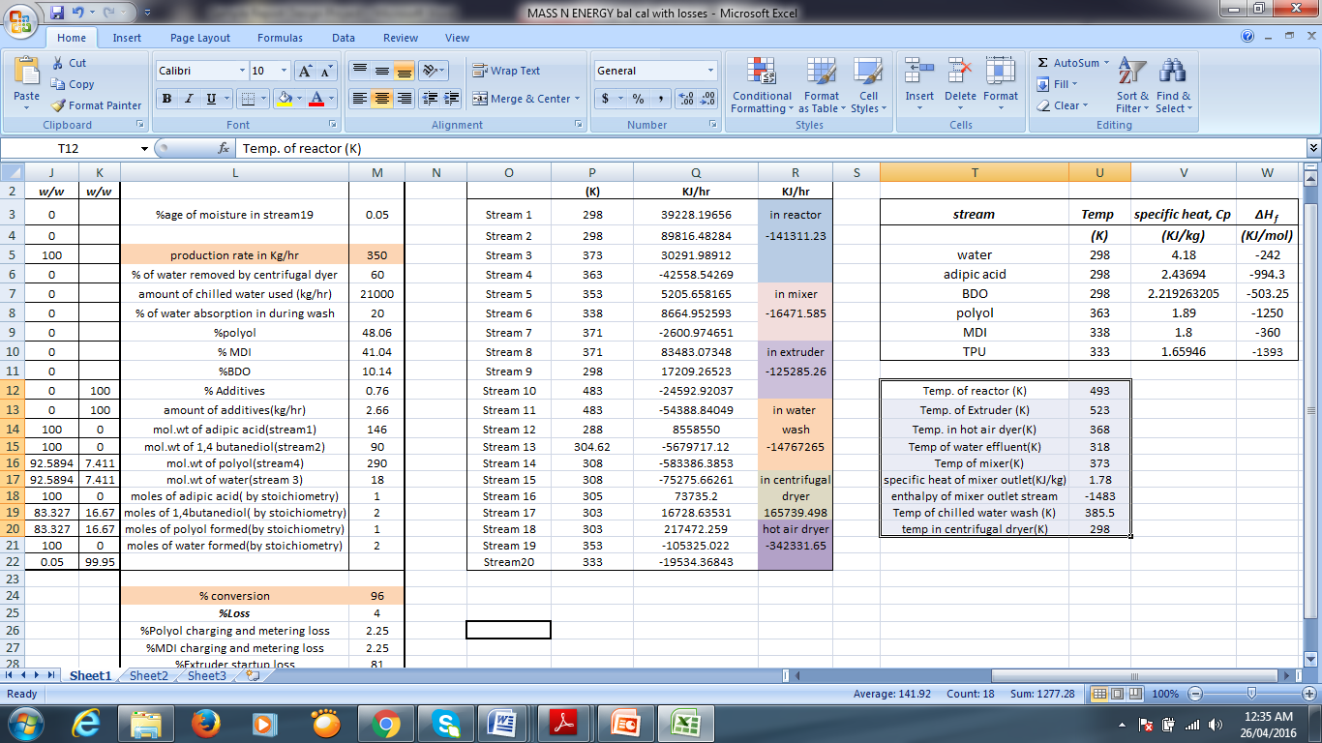

**CHAPTER 6**

**6.1 EQUIPMENT DESIGN- POLYOL REACTOR**

**CONDENSATION POLYMERISATION REACTOR DESIGN**

**Model selection reference of reaction kettle**

|  |  |
| --- | --- |
| **Composition** | **Type** |
| Specification (L) | 50-50000 |
| Design Pressure (Mpa) | Atmospheric Pressure or under pressure |
| Material | Titanium Clad steel |
| Heating Forms | Electrical heating with medium in jacket, external half coil steam heating,   external half conduction oil heating, hot water infrared heating |
| Cooling Forms | Refrigeration medium in the internal pipe jacket |
| Blending Power | Model selection is made according to material viscosity, liquid-solid ratio, liquid specific gravity, solid specific gravity, solid granularity,  rotation speed, paddle type, with or without baffle or internal coil. |
| Stirring blade Forms | Ribbon Type |
| Seal | Mechanical seal |
| Inner Surface Treatment | Polished |
| Discharge Valve | Open downward discharge valve |
| Technological Pipe Hole | Manhole, pressure  gauge port, temperature, mouth |

All parts of the equipment that contact with the material are all made by stainless steel (SS304)

**WORKING MECHANISM:**

Batch Reactor has been used. These are exclusively used for polymerization reactions. The reactants are added to the empty vessel and the contents are removed after completion of the reaction via discharge valve. The reactor temperature is maintained at 220 degrees celcius which is the condition requirement for polyol formation. A polymerization condensation reaction occurs during polyol formation which leads to the formation of water product along with polyol. This water boils at 220 degrees celcius reactor temperature and escapes out of the reactor as vapors from the vent present on the upper portion of the reactor vessel. ***A Double Helical Ribbon (DHR) agitator is used for mixing the highly viscous polyol being formed. DHR ensures efficient mixing of the polyol at higher rates in the laminar region. The velocity field produced by DHR exerts a stretching and folding action which forms Lagrangian Hyperbolic Structured cells of viscous component. A mechanical seal is used for firm attachment of the agitator.*** The reactor temperature is maintained via the cooling jacket around the reactor vessel. An ellipsoidal reactor head has been used along with a dished bottom. The stirrer should be started at the same time or 3-4 minutes after heating and should continue throughout the synthesis process*.* The total time cycle of the polyesterification reaction in this second phase can be reduced in 3 different ways:

- The flow of nitrogen can be increased with careful monitoring of glycol loss;

- The speed of the stirrer can be increased;

- Reduced pressure can be applied with special care to prevent foam rising.

**REACTOR FUNCTIONING:**

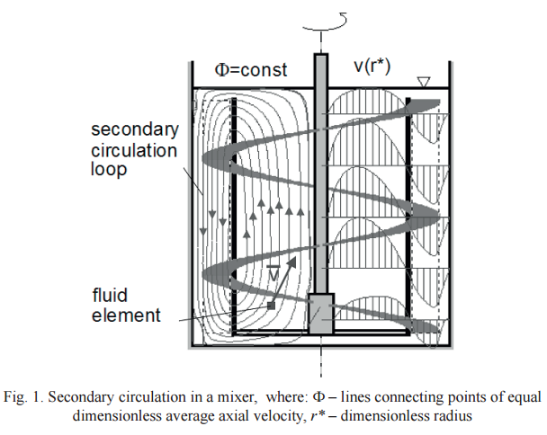

**MECHANICAL DESIGN OF REACTOR:**

**Technical parameter**

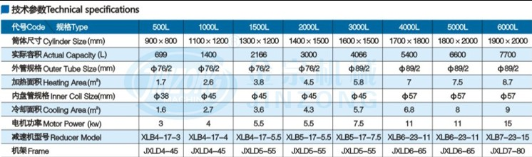

Production of polyol per batch = 350 * 6 = 2100 kg

Adipic Acid per batch = 507.85 kg

Volume of adipic acid per batch = 507.85/1344 = 0.3778 m3 = 377 L

BDO per batch = 1252.24 kg

Volume of BDO per batch = 1252.24/1017 = 1.231 m3 = 1231L

Hence total volume required = 377+1231 = 1608 L

Volume of the reactor = V = 2166 L= 2.166 m3

Assuming L/D = 1.125

V = (ΠD2/4) x L = (π/4) x 1.125*(D)3

⇒ Diameter, Di = (4V/1.125π)1/3= [4 x 0.699 / (1.125x π)]1/3 = 1.348 m

⇒ Height, L = V*4/(π x D2) = 1.518 m

**AGITATOR DESIGN:**

The diameter of helical impeller varies from 85 % of tank diameter.

Assuming that turbine operates at 70 rpm

Diameter of reactor = 1.348 m

Diameter of agitator = 85/100*Di= 0.85 x 1.348

= 1.146 m

i.e using 85% of diameter of reactor as impeller diameter

W/Da= 0.25

Width of the blade= 0.25*Da= 0.25*1.146 = 0.2865m (Optimised Blade: giving optimum performance)

Thickness of Blade= 0.005 m

Clearance= 0.01*Da= 0.01*1.146= 0.0146 m

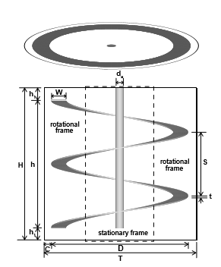

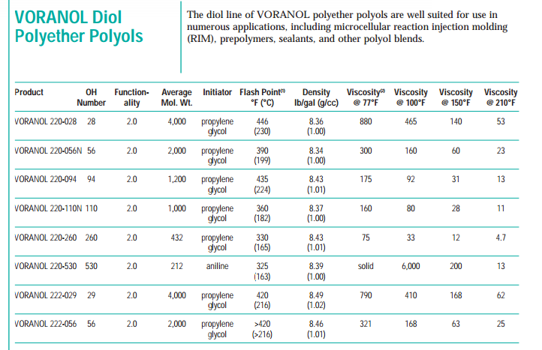

Density of polyol mixture, ρ =1000 kg/m3

Viscosity of mixture, µ = 53 cP

NRe = ρNDa2/µ = [1000x 70/60 x (1.486)2] / 53= 48.6 **(Confirming low Reynolds No. for viscous fluids)**

From M.V. Joshi, Process Equipment Design, 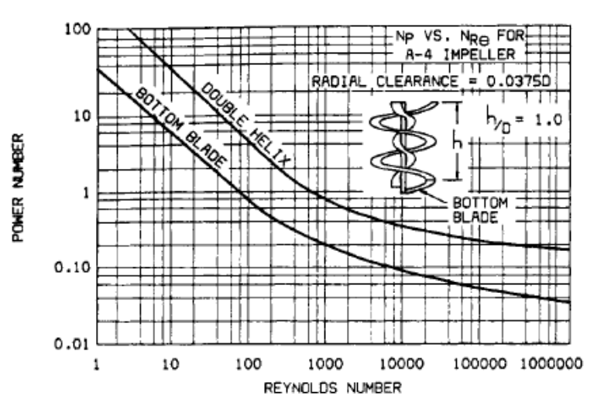

From power curve, Np = 10 for Reynolds number 48.6

Power, P = Np*ρ* N3*Da5= (10 x 1000x (70/60)3x (1.486)5) = 115062.6616 W

Power losses (10%) = 11506.2 W (helical gears have efficiency of power transmission 90%)

Power input = 115062.66 + 11506.2 = 126568.861 W

Transmission system losses (20%) = 126568.861 x 0.2= 25313.78 W

Total Power= 126568.861 + 25313.78 = 151882.64 W

This will be taken as 152000 W to allow for fitting losses. It is advisable to use 152000 W motor.

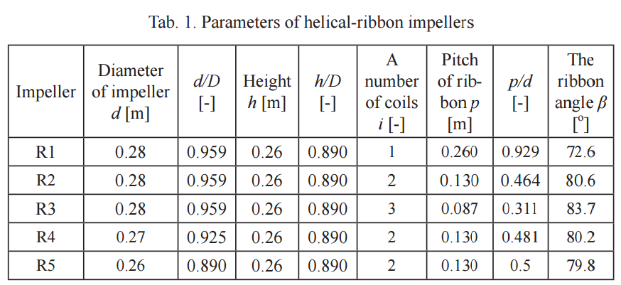

**SHAFT DESIGN:**

Continuous average rated torque on the agitator shaft, Tc= P/2 π N=

152000/ (2 π 70/60)= 20746.132 Nm

Where Tm is maximum torque= 1.5*Tc= 1.5*20746.132 = 31119.2 Nm

Polar modulus of the shaft cross section is, Zp = Tm/fs

fs =shear stress =550 kg/cm2

Zp =31119.2*100/550 = 5658 cm3 d = 10.3 cm

Π*Ds3/16= 5658

Ds = 30 cm = 0.3 m

**CRITICAL SPEED:**

Actual speed is 40% of the critical speed

Critical speed Nc= 70/0.4

= 175 rpm

Since actual shaft speed is 70 rpm which is 40% of the critical speed.

**BLADE DESIGN:**

No. of blades = 4 (for efficiency, typically 2 are used)

Using blade width, w = 0.2865m

Blade thickness, t = 0.005m

Stress in the blade, F= (maximum torque)/(tw2/n)= (31119.2)/(0.005 x 0.0.2865 2/4) =303306042N/m2= 303.3MPa < 414MPa (Ultimate Strength of Stainless Steel 2205)

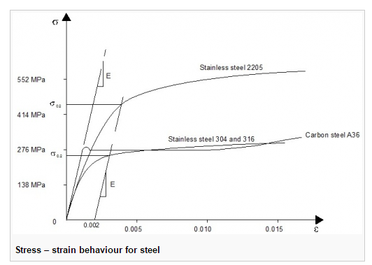

The value of stress is well within the limit for stainless steel 2205.

**MECHANICAL SEAL:**

It consists of two surfaces (rings), one on the rotating shaft and the other is stationary. It has a rotary ring made of steel which is held on the shaft by a flexible O-ring made of Teflon. A stationary ring made of carbon (low coefficient of friction) is placed in a box through another O-ring. O-ring compensates for lack of alignment, thermal expansion and shaft vibration.

**THICKNESS OF VESSEL:**

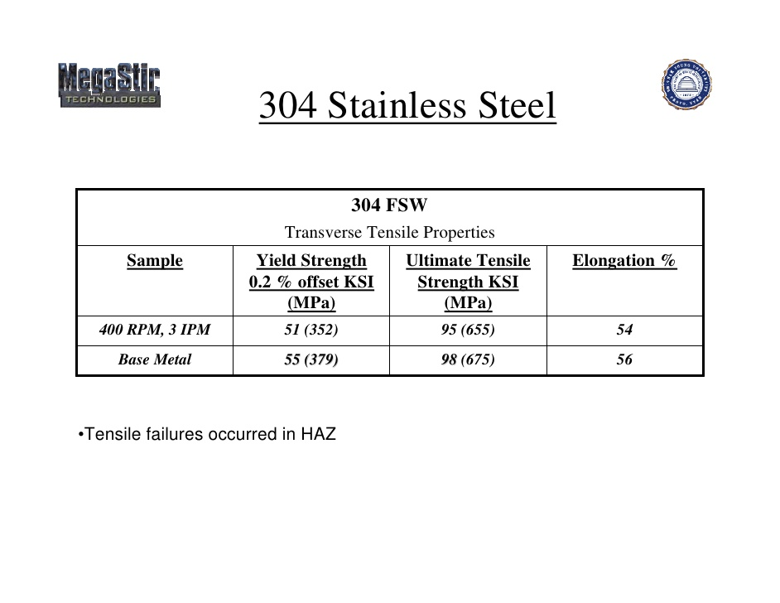

Allowable stress value, f = 650 kg/cm2 (upto 6679 kg/cm2 for Stainless Steel 304)

Thickness of reactor, t = (PDi)/[(2fj)-P] + C

Where

‘j’ is joint efficiency = 0.85

‘P’ is the design pressure

P = 1.1*30

= 1.1 x 30

= 33 kg/cm2

t = (33 x 1348)/[(2 x 650 x 0.85)-33] + 3

= 44.496 mm with corrosion allowance

Thickness of reactor vessel = t = 44.496 mm = 0.044 m

**DESIGN OF REACTOR HEAD (ELLIPSOIDAL):**

Using Flat head

Thickness of head, t = (C*Di/10)

Where ‘C’ is taken as 0.5

(IS 2825 – 1969)

t = (0.5 x 1348/10)

= 67.4 mm

= 70.4 mm with 3mm allowance for corrosion

**DISHED BOTTOM THICKNESS**

Th =PDi /2 x f x J

Th = 33 x 1348 / (2 x 650 x 0.85) + 3

= 43.25 mm with corrosion allowance

**JACKET DESIGN**

Jacket Diameter= 1.045 * 1.392 = 1.455 m

Jacket Thickness= (PDi)/[(2fj)-P] + C = 33*1455/(2*650*0.85-33) + 2 = 46.79 mm = 0.046 m

Hence approximately 0.046 m is the jacket thickness

**WEIGHT CALCULATIONS:**

Length of reactor = 1.518 m

Outside diameter of reactor = 1.392496 m

Inner diameter of reactor = 1.348 m

Density of structure steel = 8000 kg/m3 (SS304)

**Weight of reactor vessel,**

W1 = 8000 x π/4 (1.392 – 1.348) x 1.518 = 419.453 kg.

**Weight of Adipic acid,**

W2 = π/4 (Di2) L ρ

= π/4 x 1.3482 x 1.518 x 1344

= 11640.73 kg

**Weight of the head**

W3 = t x L x b x ρ

= 70.4 x 10-3x 1.518 x 1.518 x 8000 = 1297.795 kg

**Weight of the BDO**

W4= π/4 (Di2) L ρ= π/4 x 1.3482 x 1.518 x 1017= 2202.1 kg

**Weight of Agitator Assembly**

We have a motor power output of 115 kW

Matching this with the standard specifications we get the, W5= 400 kg

Total weight W = W1+ W2 + W3+W4+W5= 15958 kg

Design weight = 1.3 x 15958

= 20746.5 kg.

**PRIMARY STRESS ON VESSEL**

σb = PxDi/2t = (33 kg/cm3 x 1.348)/(2 x 0.044) = 505.5 kg/cm2

σL = PxDi/4t = 505.5/2 =252.5

σW = W/ (π x t x (Di +t)) = 20746.5 /( π x 0.044 x (1.348 + 0.044)) = 105.31 kg/cm2

σZ  Total Longitudinal stress =  σW  + σb + σL = 863.31 kg/cm2

**DESIGN OF SUPPORT**

**LEG SUPPORT**

No. of legs = 4

Base to be circular and legs are cylindrical in shape.

Maximum ratio of leg support length to diameter of vessel = 2:1 (Assuming 0.5:1 for batch reactor configurations)

Thus, Length = 1. 348 m x 0.5= 0.674 m

σZ/2 = 431.655 kg/cm2

σZ/4 = 215.827 kg/cm2

σZ/6 = 143.885 kg/cm2 Stress per base plate.

Area of leg support = Outer Dimensions of leg support2 (For square shaped plate type leg support) = 0.07m x 0.07m = 0.0049 m2

Width = 33 X 0.674 / 2 X 143.885 = 0.07 m = PxL/2t

**CHAPTER 7**

**7.1 COST ESTIMATION OF POLYOL REACTOR**

**AGITATOR**

Ribbon Blender (SS 304) costs = Rs 1525261.93 ($22957)

**REACTOR VESSEL**

(Including Jacketing, Sealing and Gears)

For a capacity of 2.1m3 and design pressure of 33 kg/cm2 , cost = Rs 13674803.39($205822)

Hence total equipment cost = 1525261.93 + 13674803.39 = Rs 15,200,065.32

(*Refered from Equipment Costs-Plant Design and Economics for Chemical Engineers 5th edition by Peter and Timmerhaus Tata Mcgraw Hills Publications*)

**7.2 ESTIMATION OF VARIABLE COST**

**RAW MATERIAL:**

Cost of Adipic acid =Rs. 500 per kg =Rs. 5 lakhs per tonne

Cost of BDO =Rs. 199.23 per kg =Rs. 199230 per tonne

For one year,amount of Adipic acid required = 2.031 tonnes/day(from material balance)

Total raw material cost=(5lakh+1.99lakh)*2.031=**14.20 Crores**

**7.3 COST ESTIMATION OF PLANT**

Capacity of plant = 350 kg/hr  
 = 8400 kg/day

Current selling Price=$20/kg

We assume that operating percentage = 95%

Therefore, annual gross sales are the product of annual production rate and the selling price per unit of production.

Basic assumption is that all product made is sold.

Annual Gross sales= $20/kg X 365 days X 0.95 X 8400 kg/days  
 =$ 5.82 X 107

With the current economy, $1=Rs. 66.41

Therefore, Annual Gross Sales = Rs. 386.502 X 107

The Turnover Ratio = 0.65 (Assumed to be of polymeric material)

Fixed capital investment = Annual Gross Sales /Turnover ratio  
 = (386.502 X 107)/0.65  
 = Rs.594.618 X 107

**ESTIMATION OF TOTAL INVESTMENT COST** :

1. Direct cost:
2. Purchased equipment cost: (15 – 40% of FCI)

Assume 40% of FCI

=Rs. 237.84 X 107

1. Installation cost: (35 -45% of PEC)

Assume 45%

=Rs. 107.03 X 107

1. Instrumentation and control installed: (6-30% of PEC)

Assume 30% of PEC

=Rs. 71.35 X 107

1. Piping installation cost: (10-80% of PEC)

Assume 80%

=Rs. 190.27 X 107

1. Electrical installation cost: (10-40% of PEC)

Assume 40% of PEC

=Rs. 95.14 X 107

1. Building process and auxillary: (10-70% of PEC)

Assume 70% =Rs. 166.5 X 107

1. Service facilities: (30-80% of PEC)

Assume 80%

=Rs 190.272 X 107

1. Yard improvement: (10-15% ofPEC)

Assume 15%

=Rs. 35.67 X 107

1. Land: (4-8% of PEC)

Assume 8%

=Rs. 19.02 X 107

Therefore direct cost = Rs. 1113.092 X 107

1. Indirect Costs: Expenses which are not directly involved with material and labour of actual installation or complete facility
2. Engineering and supervision: (5-30% of DC)

Assume 30%

=Rs. 333.92 X 107

1. Construction expenses: (10% of DC)

=Rs. 111.31 X 107

1. Contractors fee: (2-7% of DC)

Assume 7%

=Rs. 77.91 X 107

1. Contingency: (8-20% of DC)

Assume 20%

=Rs. 222.61 X 107

Therefore total indirect cost =Rs. 745.75 x 107

**FIXED CAPITAL INVESTMENT:**

Fixed capital investment (FCI): = DC+IC

=Rs. 1858.842 X 107

**WORKING CAPITAL INVESTMENT:**

(10-20% of FCI)

Assume 15%

=Rs. 278.826 X 107

**TOTAL CAPITAL INVESTMENT**: =FCI+WC

=Rs. 2137.668 X 107

**ESTIMATION OF TOTAL PRODUCT COST (TPC):**

FIXED CHARGES:

1. Depreciation: (10% of FCI for machinery)

=Rs. 185.884 X 107

1. Local taxes: (3-4% of FCI)

Assume 3%

=Rs. 55.765 X 107

1. Insurances: (0.4-1% of FCI)

Assume 0.4%

=Rs. 7.435 X 107

1. Rent: (8-12% of FCI)

Assume 8%

=Rs. 148.707 X 107

Therefore total fixed charges = Rs. 397.791 X 107

But, fixed charges = (10-20% OF TPC)

Assume 20%

Therefore total product cost=Rs. 1988.95 X 107

**DIRECT PRODUCTION:**

1. Raw materials: (10-50% of TPC)

Assume 40%

=Rs. 795.58 X 107

1. Operating labour(OL): (10-20% of TPC)

Assume 15%

=Rs. 298.34 X 107

1. Direct supervisory and electric labour: (10-15% of OL)

Assume 13%

=Rs. 38.78 X 107

1. Utilities: (10-20% of TPC)

Assume 15%

=Rs. 298.342 X 107

1. Maintenance(M): (2 – 10% of FCI)

Assume 8%

=Rs. 148.707 X 107

1. Operating supplies(OS): (10-20% of maintenance)

Assume 15%

=Rs. 22.306 X 107

1. Laboratory charges: (10-20% of OL)

Assume 12%

=Rs. 35.80 X 107

1. Patent and royalties: (2-6% of TPC)

Assume 4%

=Rs. 79.558 X 107

**PLANT OVERHEAD COST:**

50-70% of (OL+OS+M)

Assume 65%

=Rs. 305.08 X 107

**GENERAL EXPENSES**

1. Administration cost: (40-60% of OL)

Assume 50%

=Rs. 149.17 X 107

1. Distribution and selling price: (2-30% of TPC)

Assume 20%

=Rs. 397.79 X 107

1. Research and development cost: (3% of TPC)

=Rs. 59.668 X 107

Therefore general expenses (GE) = Rs. 606.628 X 107

Therefore manufacturing cost (MC) = product cost + fixed charges + plant overhead expenses

=Rs 2691.821 X 107

TOTAL PRODUCTION COST= MC + GE

= Rs. 3298.45 X 107

GROSS EARNING AND RATE OF RETURN:

The plant is working for say 345 days a year

Selling price = 20 x 66.41 =Rs.1328.2/kg

Total income = 1328.2 X 345 X 8400  
 =3849.1 X 107

Gross income = total income – total product cost  
 = (3849.1 X 107) – (1988.95 X 107)  
 =Rs. 1860.15 X 107

Assumption: Tax = 50%

Net profit =Rs. 930.075 X 107

Return on Investment (ROI) = Annual Net Profit (after taxes)/Total Capital Investment X100   
 = 930.075 X 107/(2173.668 X 107) x 100  
 = 42.78%

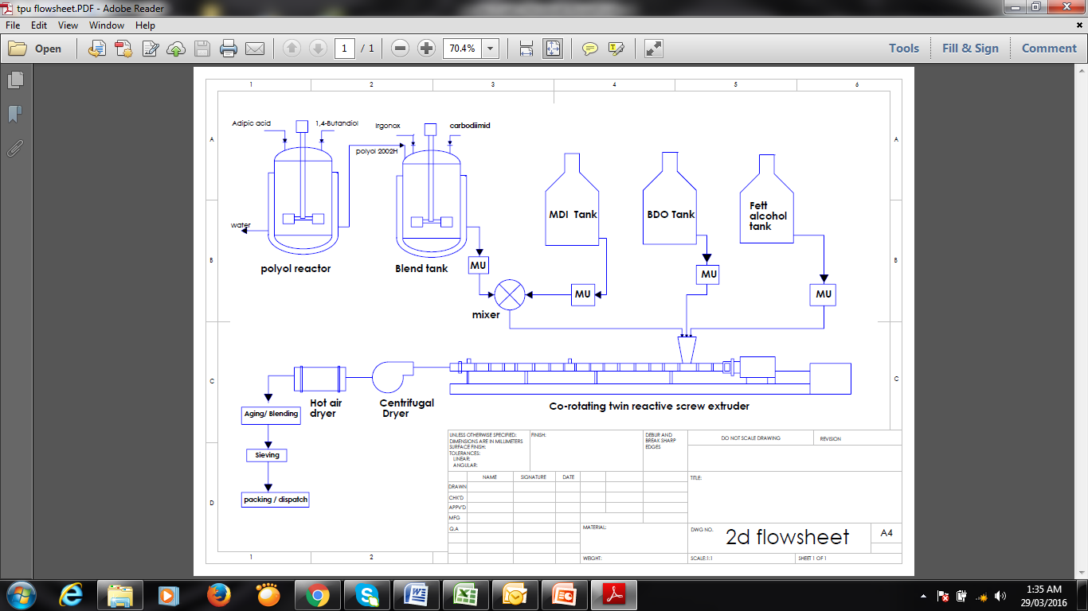

**8. CONCLUSION**

A thermoplastic polyurethane plant with a capacity of 8400 tons/day has been designed using adipic acid , 1,4 –butanediol ,MDI , Irgonox, carbodiimide , and others additives as raw material. A market survey was done to reach a concrete conclusion regarding the increasing demand of TPU globally and within the country. Thermoplastic Polyurethane has a variety of applications like it can be used for Furniture ,Automobile seats, Houses, sculptures, and decorations ,Filling of spaces and cavities, Water vessels, Flexible plastics ,Varnish, Wheels, Automotive Parts, Electronic components, Adhesives ,Abrasion resistance , Architectural Glass Lamination ,Auto-Body Side Molding ,Automotive Lumbar Supports ,Caster Wheels. Its latest field of application includes usage as foams for oil absorption in water bodies to prevent pollution, taking advantage of the high hydrophobicity and oleophilicity that dimer acids impart to the final polyurethanes.

Polymerisation condensation reaction was selected as the first step of the manufacturing process after a careful study of the problems faced during manufacture, environment concerns. Efficient use of raw materials was considered to reach an optimum efficiency level. The detailed study of the process provided a clear insight into various stages and unit operations involved in the manufacture of TPU. The project led to an understanding on the need to manage plant processes and conditions to ensure optimal plant operation. This project involves energy and material balance which led to a clearer understanding of large scale production of TPU. Equipment design of reactor was done using basics of process equipment design along with total costing of the plant which made us appreciate the practical applications of the theory learnt and understood in classes.

1. **REFERENCES**

* Perry's Chemical Engineers' Handbook-McGrawHill-8th Edition(enthalpy data)
* Coulson and Richardsons Chemical Engineering. Vol. 6 Chemical Engineering Design 4th Edition (Cost estimation and equipment design)
* Handbook of Elastomers, Second Edition, edited by Anil K. Bhowmick, Howard Stephens
* Process for the preparation of polyester polyols  US 4018815 A [Herwart C. Vogt](http://www.google.co.in/search?tbo=p&tbm=pts&hl=en&q=ininventor:%22Herwart+C.+Vogt%22), John T. Patton, Jr. (<http://www.google.co.in/patents/US4018815>)s
* <http://www.ribbonblender.in/ribbonblender.html>
* <file:///C:/Users/user/Downloads/vol5no3-11_Tsui.pdf>
* Rules of Thumb for Chemical Engineers By Stephen Hall
* <http://www.tacmina.com/agitators/>
* <file:///C:/Users/user/Downloads/Adipic%20Acid.pdf>
* Joshi’s Process Equipment Design ,4th edition, V. V.Mahajani , S.B. Umarji
* <http://www.mhhe.com/engcs/chemical/peters/data/ce.html>
* Equipment Costs-Plant Design and Economics for Chemical Engineers 5th edition by Peter and Timmerhaus Tata Mcgraw Hills Publications
* Unit Operations in Chemical Engineering Mcabe and Smith
* Chemical Engineering Design 5th Edition Ray Sinnot